Application Architecture

An applications architecture describes the behavior of [applications](https://en.wikipedia.org/wiki/Application_software) used in a business, focused on how they interact with each other and with users. It is focused on the data consumed and produced by applications rather than their internal structure. In application portfolio management, the applications are usually mapped to business functions and to application .

### ****One Tier Architecture:****

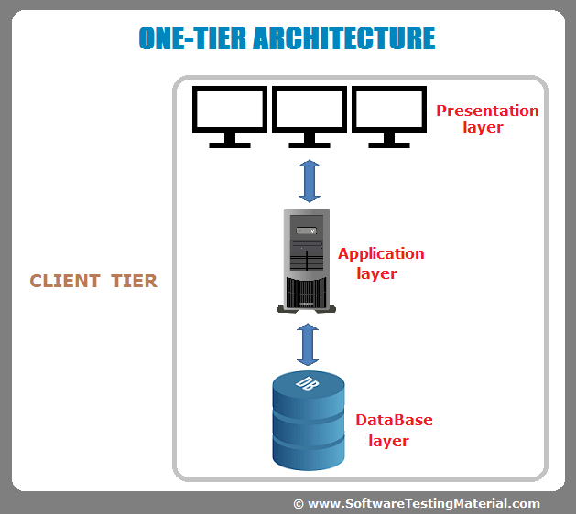

One tier architecture has all the layers such as Presentation, Business, Data Access layers in a single software package. Applications which handles all the three tiers such as MP3 player, MS Office are come under one tier application. The data is stored in the local system or a shared drive.

### ****Two-Tier Architecture:****

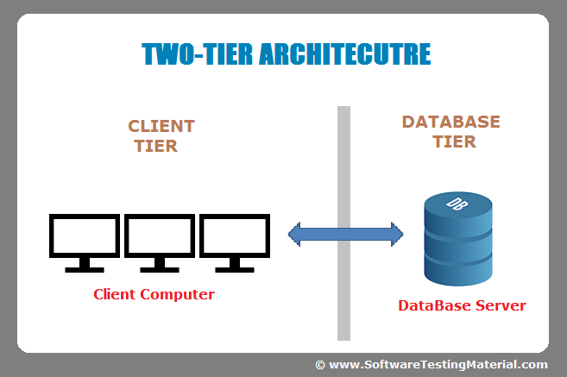

1. Client Application (Client Tier)  
2. Database (Data Tier)

Client system handles both Presentation and Application layers and Server system handles Database layer. It is also known as client server application. The communication takes place between the Client and the Server. Client system sends the request to the Server system and the Server system processes the request and sends back the data to the Client System

### ****Three-Tier Architecture:****

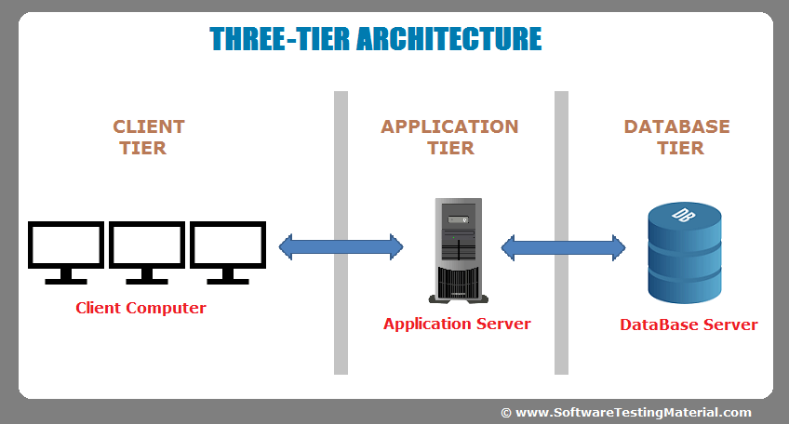

1. Presentation layer (Client Tier)  
2. Application layer (Business Tier)  
2. Database layer (Data Tier)

Client system handles Presentation layer, Application server handles Application layer and Server system handles Database layer.

1. Presentation layer (Client Tier)  
2. Application layer (Business Tier)  
2. Database layer (Data Tier)

Client system handles Presentation layer, Application server handles Application layer and Server system handles Database layer.

Another layer is N-Tier application. N-Tier application AKA Distributed application. It is similar to three tier architecture but number of application servers are increased and represented in individual tiers in order to distributed the business logic so that the logic will be distributed.